NI-CO Publication Definition Document

All information listed below can be obtained by request to:

nicohq@nico.org.uk
or by post:
Administration
NI-CO Limited
Landmark House
5 Cromac Quay
Belfast
BT7 2JD

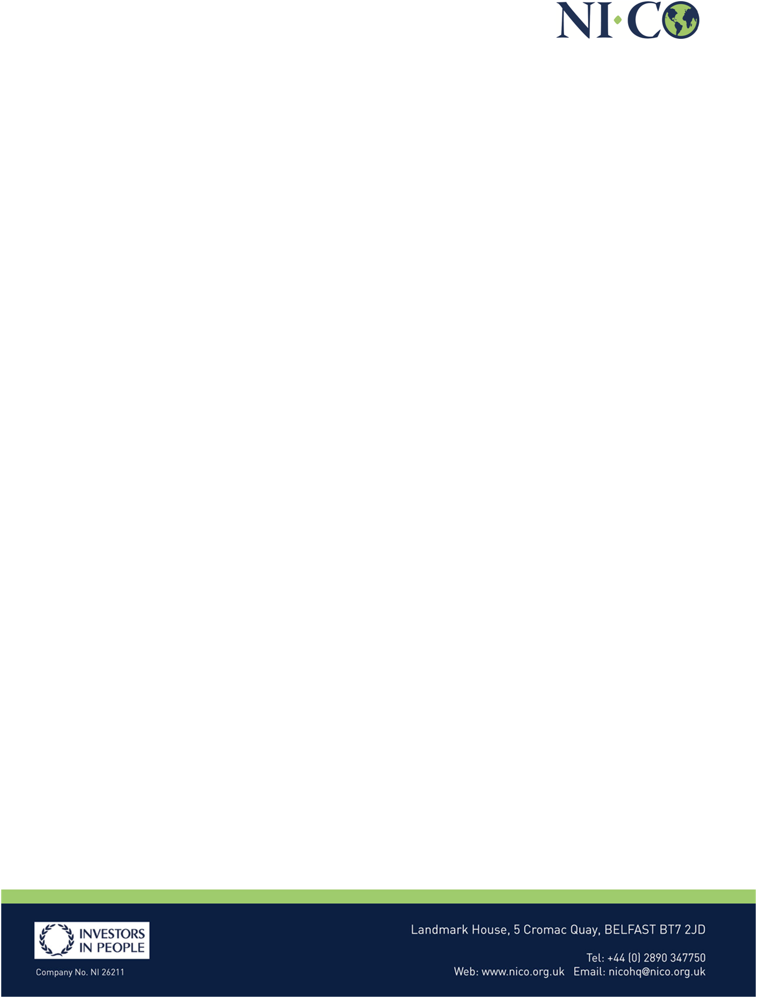
Who we are and what we do
Organisational Chart

What we spend and how we spend it

Annual Report Invest NI 2018-2019 (NI-CO is wholly owned and is a subsidiary of Invest Northern Ireland. NI-CO’s accounts are consolidated within Invest Northern Irelands).

What are our priorities and how are we doing
Annual Accounts

How we make decisions
Major policy and proposals are made at board level. Details of these will be included in board minutes.

Our policies and procedures
A list of our policies and procedures

Lists and registers
Register of Interests
Gifts and hospitality register available on request.

